***Empowering The Future: A Literacy Rate Analysis For A Better Future Tomorrow***

**INTRODUCTION**

“Empowering the future” is a research project examining global literacy rates, disparities, and technology’s impact. It aims to raise awareness, advocate for policy changes, and inspire collaboration among stakeholders for improved literacy access, fostering a brighter and inclusive future for individuals and communities worldwide.

* **OVERVIEW:**
* Empowering the future through an analysis of literacy rates is crucial for creating a better tomorrow. By improving literacy rates, individuals can access better education, job opportunities, and overall quality of life.
* It enhances critical thinking and problem-solving skills, leading to a more informed and engaged society. Governments and organizations should invest in education and literacy programs to ensure a brighter future for everyone.
* To know development in a society, literacy is another proper indicator of economic development.
* For purpose of census, a person is age limit of seven and above, who can both read and write with understanding in any of the language is considered as a literate in India. Literacy plays a major role in the economic development of a nation. Compared with other nations, Republic of India has the largest illiterate population.
* **PURPOSE:**
* The purpose of empowering the future through a literacy rate analysis is to identify areas with low literacy rates and implement targeted strategies to improve them. By understanding the literacy challenges in different regions and communities, governments, policymakers, and organizationscan design effective interventions to raise literacy levels.
* A higher literacy rate ensures that more individuals have access to education, which fosters personal development and economic growth. It also promotes social inclusion and reducesinequalities. Ultimately, improving literacy rates contributes to creating a more knowledgeable, skilled, and empowered society, which paves the way for a better future tomorrow and beyond.
* Majority of states in India has shown majors signs of improvement in their overall illiteracy rate thus contributing towards a literate nation.
* Here we are analysis literacy rate in India for 2021. This dataset contains a record literacy rate each states of India, here we are going to analyse state wise, region wise and overall literacy rate among children, women and men in India in India.

**LITERATURE SURVEY**

* **PROBLEM STATEMENT:**
* “Empowering the future: A literacy Rate Analysis for a Better Future Tomorrow” seeks to explore global literacy rates, regional disparities, gender inequalities, and socioeconomic factor. It aims to address challenges faced by those with limited literacy skills and examine literacy transformative power in personal development, social progress and economic growth. The project also investigates technologies `role in enhancing literacy acquisition and bridging the digital divide, advocating for improved literacy access and empowering on a global scale.
* Literacy rate analysis involves the study of the percentage of a population this type of analysis is often conducted at the national or regional level and relies on data from sources such as national censuses, largescale surveys, educational institutions and other sources. The results of literacy rate analysis can be used to inform policy and decision-making at the national and local level, and to
* Guide efforts to improve education and literacy in a given population this type of analysis is important for understanding.

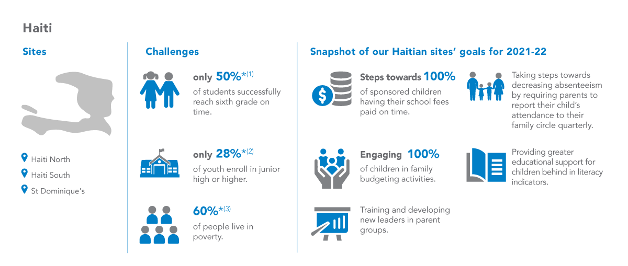

* **PROPOSED SOLUTION:**

* *Idea/solution description:*

Empowering the future is a project aimed at analyzing global literacy rates and identifying effective strategies for improvement. The project focuses on factors such as education policies, economic development, and resoures access, with the goal of empowering individuals and creating a better future for all.

* *Novelty/Uniqueness:*

Empowering the future takes a holistic approach to analysing literacy rates, in corporating diverse factor such as education policies and economic development. By leveraging AI and data analysis, the project aims to identify new and innovative solutions to improve literacy rates and empower individuals for a better tomorrow .

* *Social impact /customer satisfication*:

Empowering the future’s customer satisfication is driven by its ability to provide insightful analysis and innovative solution for improving literacy rates. The project’s holistic 14 approach, leveraging Ai and data analysis, ensures that strategies are tolored to meet the unique needs of individuals and communities, resulting in greater empowerment and better future

* *Business Model(Revenue Model):*

Empowering the future’s customer satisfaction is driven by its ability to provide in sightful analysis and innovative solutions for improving literacy rates. The project’s holistic 14 approach, leveraging AL and data analysis, ensures that strategies are tailored to meet the unique needs of individuals and communities, resulting in grater empowerment and aa better future.

* *Scalability of the solution:*

Empowering the future’s scalable solutions relies on leveraging AI and data analysis to analyse global literacy rates and provide tailored solutions for improvement. Through partnerships with governments and NGO’s, the project aims to scale its impact by empowering individuals and communities with the skills and knowledge they need succeed.

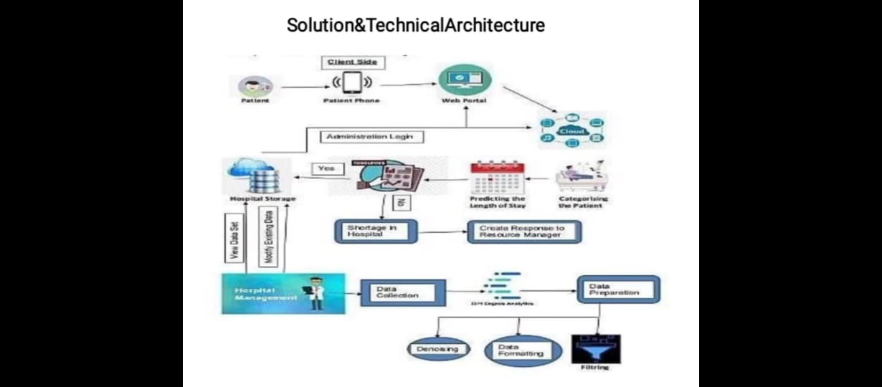

* **IMPLEMENTATION OF THE SOLUTION:**
* *Data collection:*

Gather data on literacy rates from various sources, including government reports, international organization, and academic studies. Additionally, collect data on factors influencing literacy, such as socioeconomic status, gender, geographical location, and education policies. Ensure data is reliable and representative of the target population.

* *Identifying challenges:*

Identify challenges faced by communities low literacy rates. Conduct interviews, surveys, or focus groups to gather qualitative insights and understand the barrier to accessing education.

* *Monitoring and Evaluation:*

Establish a monitoring and evaluation framework to track the progress of literacy improvement initiatives. Regularly assess the impact of interventions and make necessary adjustments as needed.

* *Data analytics and insights:*

Clean and preprocess the collected data to eliminate inconsistencies and missing values. Convert raw data into a usable format for analysis.

**TECHNICAL ARCHITECTURE**

* 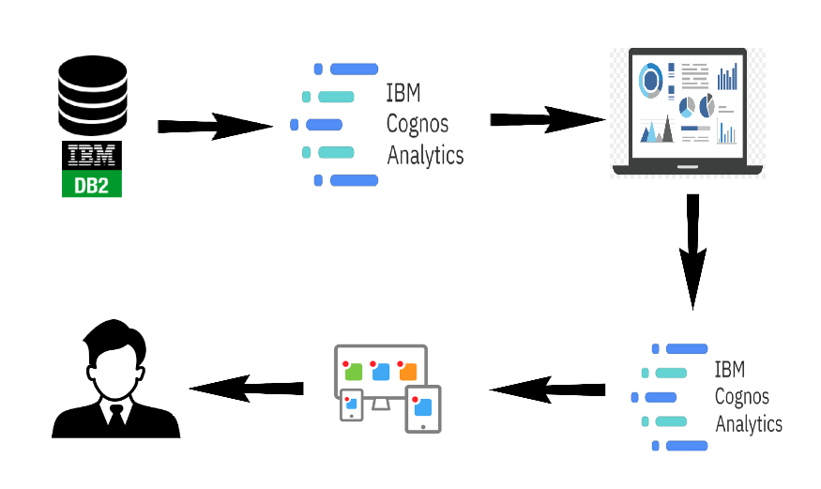**DIAGRAMMATIC OVERVIEW OF THE PROJECT**

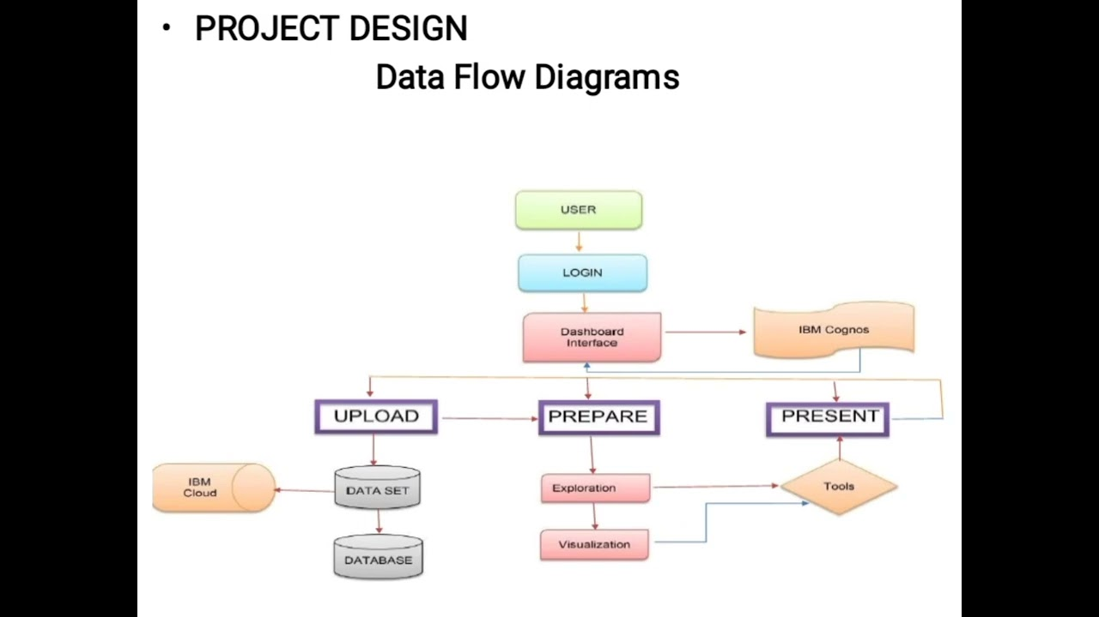

* **HARDWARE AND SOFTWARE REQUIREMENTS:**
* *Hardware Requirements:*
* Accessible Devices: Ensure widespread availability of affordable and user-friendly devices like smartphones, tablets, and computers to access educational resources.
* Internet Connectivity: Broadband internet access to facilitate online learning, access to digital libraries, and interactive educational content.
* Infrastructure: Establishing educational institutions with well-equipped classrooms and computer labs in areas lacking adequate facilities.
* Power Supply: Reliable electricity to ensure uninterrupted access to technology.

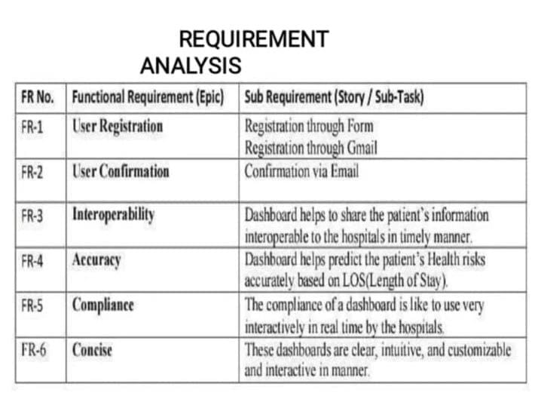

To empower the future and improve the literacy rate, a comprehensive requirement analysis is essential. This analysis should include evaluating the current literacy levels, identifying barriers to education, assessing available resources, developing targeted educational programs, and engaging the community to support the initiative. Additionally, technology integration, teacher training, and continuous monitoring and evaluation would be crucial to ensure sustained progress towards a better future with higher literacy rates.

* **NONFUNCTIONAL REQUIREMENTS**

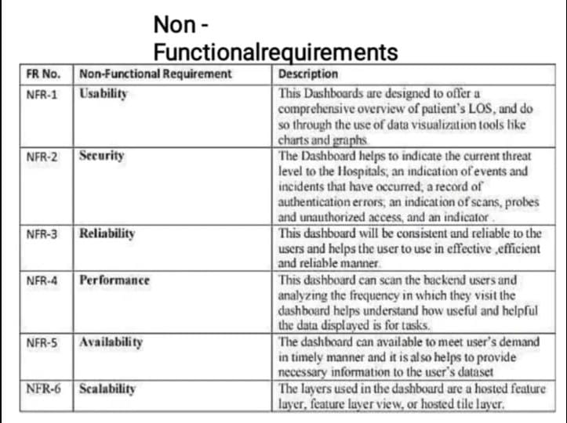

* Non-functional requirements for empowering the future and improving literacy rates may include:
* Scalability: The program should be designed to accommodate a growing number of learners and expand its reach over time.
* Accessibility: Educational materials and programs should be easily accessible to individuals with disabilities or from marginalized communities.
* Reliability: The system should be reliable and available to learners consistently, minimizing downtime or disruptions.
* Security: Data privacy and protection measures must be in place to safeguard sensitive information of learners and stakeholders.
* Performance: Educational platforms should be responsive and able to handle multiple users simultaneously without significant delays.
* Usability: The user interface should be intuitive and user-friendly, catering to learners of different ages and technological backgrounds.
* Compatibility: The platform and materials should be compatible with various devices and operating systems to reach a broader audience.
* **FUNCTIONAL REQUIREMENTS:**
* Empower the future and improve literacy rates for a better tomorrow, some functional requirements could include:
* Accessible Education: Ensure easy access to quality education for all, regardless of location or socio-economic status.
* Digital Literacy Programs: Implement initiatives to promote digital literacy and technological skills among students and adults.
* Teacher Training and Development: Provide ongoing training and support for educators to enhance teaching methods and strategies.
* Multilingual Education: Offer education in multiple languages to cater to diverse communities and facilitate better learning outcomes.
* Community Engagement: Involve local communities in educational activities and encourage parental involvement to create a supportive learning environment.
* Curriculum Enhancement: Continuously update and improve the curriculum to align with current needs and prepare students for future challenges.
* Infrastructure and Resources: Invest in modern infrastructure, learning materials, and technology to enhance the learning experience.
* Monitoring and Evaluation: Establish a robust system to monitor literacy rates and educational progress to identify areas for improvement.
* Collaborations and Partnerships: Foster partnerships with NGOs, private organizations, and government agencies to collectively work towards improving literacy rates.
* Inclusive Education: Implement inclusive practices to accommodate learners with diverse abilities and ensure equal opportunities for everyone.
* By addressing these functional requirements, we can work towards empowering individuals through education and ultimately create a better future with higher literacy rates and improved socio-economic development.

**RESULT**

Empowering the future with a higher literacy rate can lead to a more analytically adept society, creating a better tomorrow through improved critical thinking, innovation, and informed decision-making. A literate population can better understand complex issues, engage in lifelong learning, and contribute to the growth of their communities and the world at large.

**ADVANTAGES AND DISADVANTAGES**

* **ADVANTAGES:**
* Understanding the literacy rate in India can also businesses keep track of government policies and initiatives aimed at improving literacy rates.
* Businesses need to understand the literacy rates in India to conduct market research and determine the potential customer base for their products or services.
* Enhanced Problem-Solving: A literate and analytically skilled population can better identify and tackle complex problems, leading to improved socio-economic development.
* Innovation and Creativity: High literacy and analytical abilities foster creativity and innovation, encouraging individuals to come up with new ideas and solutions.
* The ultimate goal is to gain insights and improve performance through data visualization techniques.
* The literature survey for literacy rate analysis involves reviewing academic articles, and other sources related to the analytics of literacy rate.
* Informed Decision-Making: A well-informed society can make better decisions, both at the individual and societal levels, leading to more effective governance and policies.
* Economic Growth: Increased literacy and analytical skills can boost productivity, attract investments, and create a skilled workforce, contributing to economic growth
* Reduced Poverty: A literate population has better access to job opportunities, which can help alleviate poverty and improve the overall standard of living.
* The literacy rate analysis in India can help businesses make informed decision, improve their marketing efforts, plan their workforce, and contribute to social causes, among other benefits.
* **DISADVANTAGES:**
* We have people with insufficient information, as well as those with disinformation, mixed in the group with those who simply want to provide the TRUTH about a subject of internet.
* Just knowing the truth and providing it to the public is to easy task when you are computing with such thick bias, such as what we have in society today.
* Inequality: Empowering only a portion of the population with literacy and analysis skills may lead to a knowledge gap, exacerbating socio-economic inequalities.
* Educational Challenges: Implementing and maintaining comprehensive literacy programs can be resource-intensive and may face obstacles in certain regions or communities.
* A lot of consumers don’t know who to believe, and some believe the wrong sources.
* Resistance to Change: Some individuals or communities might resist embracing new analytical methods or literacy initiatives due to cultural or social factor.
* **APPLICATIONS:**
* The applications of empowering the future through literacy rate analysis for a better tomorrow include:
* Educational Policy and Planning: Using literacy rate analysis, governments and organizations can identify regions or groups with low literacy rates and formulate targetedpolicies to improve access to quality education and resources.
* Resource Allocation: By understanding literacy trends, funds and resources can be allocated more efficiently to enhance educational infrastructure, teacher training, and learning materials in areas that need it the most.
* Early Intervention Programs: Literacy rate analysis can help identify children at risk of falling behind in their reading and writing skills. Early intervention programs can be designed to provide extra support and improve literacy outcomes.
* Workforce Development: Analysing literacy rates can help tailor vocational training programs to meet the demands of the job market, ensuring a skilled and competitive workforce.
* Social and Economic Development: Improved literacy rates lead to higher employability, increased earning potential, and greater participation in economic activities, contributing to overall social and economic development.
* Empowerment of Marginalized Groups: Literacy rate analysis can highlight disparities among different socioeconomic groups, empowering policymakers to implement targeted initiatives that address these disparities.
* Digital Literacy Initiatives: With technological advancements, digital literacy is crucial for future success. Analysing literacy rates can guide the development of digital literacy programs to ensure people are equipped with essential digital skills.
* Health Literacy: Understanding literacy rates can aid in designing health education programs that promote better health outcomes and preventive measures within communities.
* Research and Data-Driven Decision Making: Literacy rate analysis generates valuable data that researchers and policymakers can use to make informed decisions and track progress over time.
* Global Development Initiatives: International organizations can leverage literacy rate analysis to prioritize support for countries with low literacy rates, contributing to global efforts in achieving sustainable development goals.
* Overall, empowering the future through literacy rate analysis is a vital step towards building a more educated, informed, and equitable society for a better future.
* **CONCLUSION:**

Empowering the future through improved literacy rates is essential for a better tomorrow. Higher literacy rates lead to a more educated and informed society, fostering economic growth, reducing poverty, and promoting social cohesion. Enhanced access to education and literacy programs can empower individuals to make better-informed decisions and contribute positively to their communities. Investing in education and promoting literacy is a crucial step towards creating a brighter and more equitable future for all.